The City of Charleston is honored to recognize El Informador Newspaper as our Quarterly M&WBE Spotlight!


El Informador Newspaper
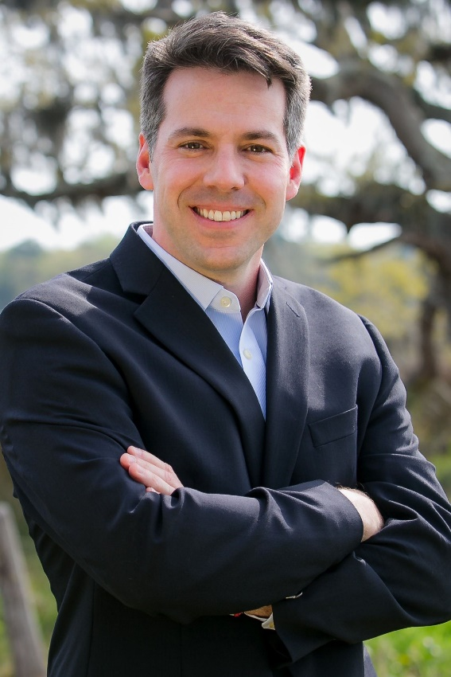
Owner: Pedro De Armas
Email Address: pedro@elinformador.us
Address: 222 W. Coleman Blvd, Suite 111, Mount Pleasant
Phone: 8438172896
Website: www.elinformador.us
How long have you been in business? 13 years, 5 months
Number of employees: 4 Fulltime/3 contracted

Please give us a brief description of the business:
Spanish & Portuguese language newspaper publication available in print and digital with daily local news online. El Informador provides hyperlocal content about the coastal region of South Carolina, keeping our readers informed of the resources available, events, alerts and news in their language.

What is your business philosophy/mission statement?
Encourage access and connection to local resources and services, health education, immigration and legal aid available in Spanish, while allowing space for Latino voices to be heard and pertinent local news to be shared.

Why does this business deserve to be a M&WBE Spotlight Business?
Not only is El Informador's entire staff represented by women and/or minorities, its Latino readership also represents a minority community, making El Informador a perfect example of minority business serving a minority community. For the past 13 years we have shined our own spotlight on so many Latino community leaders, crucial information our readers would otherwise have limited access to, and necessary connections between state/government agencies, non-profit organizations and local businesses for the betterment of our community. Our focus on health disparities in the Latino community has provided a platform to educate about physical and mental health with various partnerships including MUSC Hospital and the Mental Health Department. Our dedication to the prosperity of Latinos living in the Lowcountry goes beyond just reporting the news. We get involved and seek to improve access in all areas at every turn.

Growth: How has this business grown since its establishment (in employees or revenue)? What is the vision and potential for growth in the future?
Since El Informador was launched in 2008, it has grown from serving the Charleston Tricounty via a print publication to now include the Hilton Head region and 3 additional distribution channels: web, e-publication and social networks. Additionally, we started with a team of 3 and grew to include 7 employees and tripled our revenue. We have plans to expand our digital readership reach over the next 12 months, providing more local content via direct email and promoting our recently implemented membership option.

What activities does your business engage in to support the broader community? For example: hiring veterans, charity work, volunteerism, etc.
El Informador's Editor in Chief, Pedro De Armas, was appointed by Mayor Tecklenburg as the Government Relations Chair of his Latinx Advisory Council. Pedro also serves on the board of the Latinx Echange Club of Charleston with the purpose of civic engagement and improving living standards for local Latinos. El Informador has always covered and promoted offerings and events for the non-profit sector that help local Latinos to meet their needs, inviting the community to get access to free or low-cost benefits throughout the Charleston Tricounty area like food distributions. Before COVID-19 hit, we organized a successful Latino Job Fair for the Lowcountry with 30 businesses represented. During the pandemic, we partnered with MUSC Hospital to share crucial information and with SCDHEC and Fetter Health to identify and connect them to the best locations for testing/vaccination within the dense Latino population areas. El Informador sponsored and our staff volunteered to help people complete the Census 2020 during an event with Trident United Way in both Spanish and Portuguese.

What sets your business apart from competitors?
El Informador is the largest Spanish language publication serving coastal South Carolina and the only Charleston-based business providing consistent news to local Latinos. We provide local content with original stories. We are also the only local publication that is serving both the Spanish and Portuguese speaking community. We encourage Latino entrepreneurship with our Otro Nivel business section where we highlight Latino-owned business success stories as content - 32 businesses to date.

What's one valuable lesson you've learned that you would share with other business owners?
- Creativity and Innovation of new product offerings and services for your business is crucial to stay relevant and competitive.
- Reinvent new ways to better the community that align with your business’ strategic goals.
- Be bold and consistent with your goals and mission.

Tell us an interesting and fun fact about your business:
Interesting fact - El Informador officially became a bilingual product in 2019 when we launched the first Portuguese language section, Suas Noticias, dedicated to provide information to the growing Brazilian community, estimated to be over 15,000 in the Charleston Tricounty area.
Fun fact - Our editor in chief, Pedro De Armas, is also a Television Actor from Venezuela, with over 35 TV commercials, and many Soap Operas from the age of 7 to 23 in his hometown of Caracas.

