M&WBE August Spotlight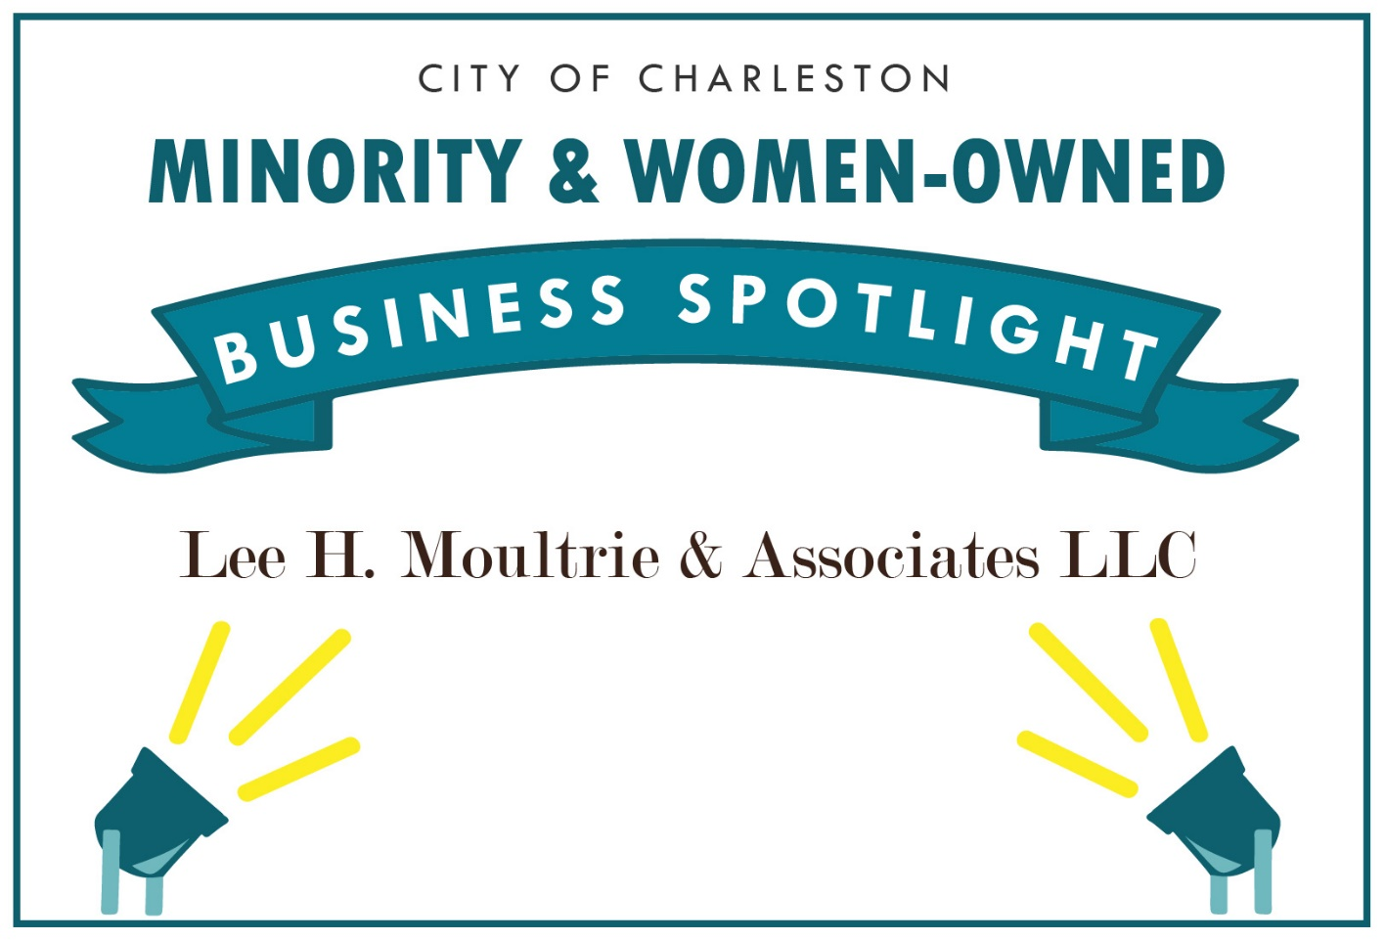

Lee H. Moultrie & Associates, LLC
Owner or Manager: Lee H. Moultrie
Address: 6650 Rivers Avenue North Charleston SC 29406
Email: LeeMoultrie@LeeHMoultrie.com
Website: www.leehmoultrie.com
Phone: (843) 882-5525
How long have you been in business?: 9 years
Number of employees: 1

Please give us a brief description of the business:
At Lee H. Moultrie & Associates, LLC our business model is to show the value of partnership, collaboration and taking advantages of opportunities that many may not see the value in immediately.
Lee Moultrie is a Community Organizer and an 18 year U.S. Air Force Veteran who started his own consulting firm in 2008. Since retiring from the Air Force in 1994, Lee has attended numerous courses and seminars in the health care field and has devoted much of his career to public outreach efforts to promote health and wellness awareness and to assist those suffering from chronic illnesses.

What is your business philosophy/mission statement?
Our mission is to bring individuals, organizations and businesses together too achieve a mutually successful goal; especially in the arena of Economic Empowerment.

Why does this business deserve to be a M&WBE Spotlight Business?
It will be an honor for our business to be selected as the M&WBE Spotlight to demonstrate to others, that we should seek to learn what an opportunity truly looks like outside of a beautiful box or all dressed up...

Growth: How has this business grown since its establishment (in employees or revenue)? What is the vision and potential for growth in the future?
We started out working with local Chef Kimberly Brock Brown in her catering business, helped her write her first book and now she has ascended to becoming the first woman and person of color to serve as the President of the American Culinary Federation in 92 years...effective August 2021. As a native of Charleston, this Chef will make Charleston and South Carolina a little larger to many in the food arena thanks to a little assistance through our company 10 years ago.

What activities does your business engage in to support the broader community?
As a U.S. Air Force Retired member, I'm a member of the Palmetto Military Support Group, and the Elite Business Owners (Veteran Business Owners), Volunteering through many organizations within our local community, especially with Starbucks to engage more mentors of color and Starbucks to assist with the School book bag donations, member of the Charleston Hispanic Association, Sophia Institute for Social Justice along with being a member of the North Charleston Chamber of Commerce . Also a member of the local Chefs association of Charleston and Board member of Father to Father, Inc.

What sets your business apart from competitors?
What sets our business apart from others is that we're always building on the local, regional, state, national and International levels. (and or building relationships for greater impact).

What's one valuable lesson you've learned that you would share with other business owners?
A valuable lesson that I would like to share with other business owners is; learn to appreciate Delayed Gratification on many levels.

Tell us an interesting & fun fact about your business:
Our business , being tagged "The Connector" and always looking to build relationships with anyone and any entity; I was able to have breakfast with the Ministry of Economics for the Government of Qatar in North Charleston....with 25 of the representatives from that Country....I was dumb founded and or at a loss for words for a few minutes as I was in the presence of this type of real money.....But, when you get an opportunity to be in the room and at the table....join in...and I did get my voice back...still connected after 4 years...

