MCC Property Solutions, Inc.
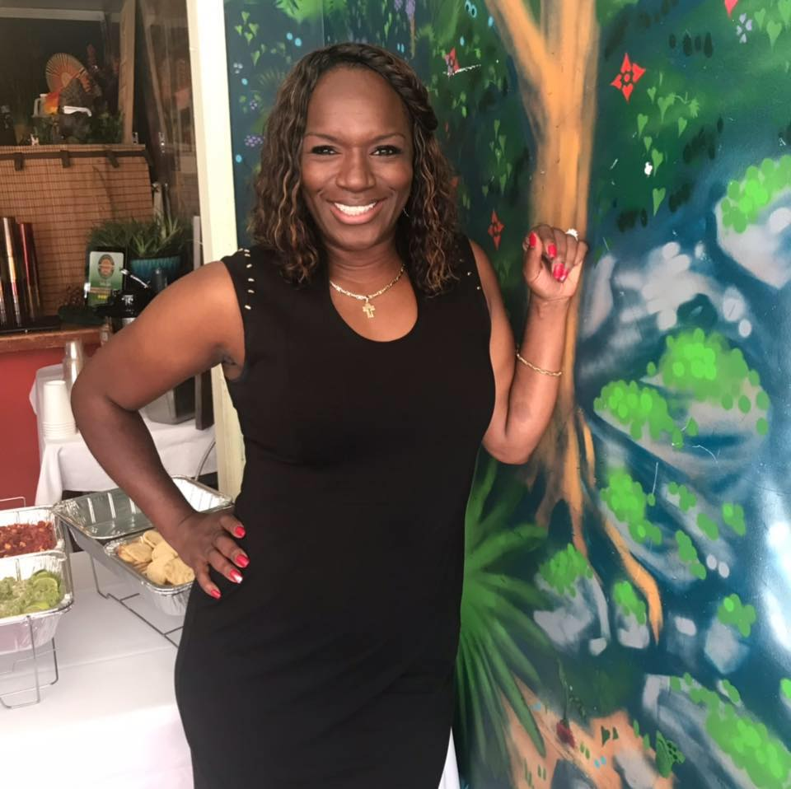
Owner or Manager: Shawntelle Matney
Address: 243 Decatur Drive, Summerville SC 29486
Email: smatney@mccpropertysolutions.com
Website: http://www.mccpropertysolutions.com/
Phone: (808) 343-6245
How long have you been in business?: 6 years
Number of employees: 2

Please give us a brief description of the business:
MCC Property Solutions, Inc., is a full service construction services company dedicated to building and developing residential structures throughout the Lowcountry. Founded in 2015 and based in Summerville, our team brings thirty-eight years of construction experience and 35 years of leadership and management to each of our projects. We specialize in new construction and full residential renovations.

What is your business philosophy/mission statement?
When a dedicated team of talented professionals has a strong desire to help others and they possess a passion for real estate, the possibilities are endless! At MCC Property Solutions, Inc., it is their mission to not only positively affect their clients; but also, to inspire, influence and produce measurable change in everyone they encounter. Shawntelle and Tommy hold themselves to the highest standards and their integrity is uncompromised. Each client is treated with the utmost dignity and respect. The Company's motto, inspired by Colin Powell is "A dream doesn't become reality through magic; it takes sweat, determination and hard work." The company is dedicated to process improvement, continuous education and professional growth.

Why does this business deserve to be a M&WBE Spotlight Business?
MCC Property Solutions, Inc., has been an absolute stewart and shining demonstration of how utilizing the services and resources of the M&WBE Certification can help grow and scale a business. She has been recognized most recently in an article published in the Lowcountry Graduate Center's online publication The Journal for becoming a M&WBE Certified company. https://www.lowcountrygradcenter.org/journal/ Additionally, on National Women's Day 2021, she was interviewed by reporter Cait Preztak from WCBD-TV Channel 2 News about being a business woman in the Lowcountry. Shawntelle's resilience and business acumen has helped catapult her business in the wake of losing her husband in August 2020. She has proven that it is not about how one falls; but rather how one recovers from that fall. MCC Property Solutions, Inc., not only has capitalized on the enhanced contracting opportunities offered by the M&WBE Office; but also has made use of the free referral to educational programs while simultaneously networking and collaborating with other diversity programs and organizations referred to by the M&WBE Office.

Growth: How has this business grown since its establishment (in employees or revenue)? What is the vision and potential for growth in the future?
MCC Property Solutions, Inc., has consistently grown stronger and better as each year passed; however, the true growth was not recognized until we decided to shift our focus by offering construction services to general public and bidding on contracts with various departments within the City of Charleston. Long-term vision and planning has our organization deeply engaged in sustainability issues and concerns. Research and Market indicated that "sustainability will go beyond compliance to regulations and will become a people's movement as greater awareness of limited resources is realized". Conversely, standard, prefabricated, modular concepts will enhance compatibility among building and infrastructure projects, improve economies of scale, enhance productivity, and accelerate the industrialization of the construction industry (Research and Market, 2021).
Another area for potential growth is developing business models that are technology and data-driven. The data suggests that with an aging workforce and digitization, the construction industry will be forced to adapt better workforce management strategies to accommodate urbanization and Generation Z. MCC Property Solutions, Inc., has the requisite qualified leadership teams to bridge the gaps in technology and the most skilled and trained professionals that can compete any residential job.

What activities does your business engage in to support the broader community?
Shawntelle is a retired Navy Chief Petty Officer who after retirement, continues serving in her community. Prior to COVID-19, MCC Property Solutions, Inc., was highly engaged in community outreach events in Charleston, Dorchester, and Berkeley counties. We continue to provide free roofing and other contracting services for families in need, disabled veterans, elderly, and/or families experiencing financial hardship. As a Fellow, of the James E. Clyburn Political Fellowship, Shawntelle also incorporates voters education, registration, and participation in her community outreach activities. Additionally, as member of the National Small Business Association’s (NSBA) Leadership Council Advisory Board, Shawntelle serves as member of the Economic Development (ED) Committee that oversees all issues relating to small-business finance and access to capital, including credit cards, lending, bankruptcy law, securities issues and venture capital. Her committee also deals with federal small-business programs under the U.S. Small Business Administration as well as federal procurement initiatives and international trade, and also handles innovation and technology issues such as patent reform. Lastly, Shawntelle is a proud and active member of Summerville Alumnae Chapter of Delta Sigma Theta Sorority, Incorporated.

What sets your business apart from competitors?
What sets MCC Property Solutions, Inc. apart from competitor is the effective use of systems and its genuine commitment to provide customer service with a purpose.
MCC Property Solution, Inc. and its team members are committed to excellence and the entire team fully subscribes to a few critical foundational attributes that have proven to be instrumental in the growth and success of the business.
At MCC Property Solutions, Inc., we strive to:
• Keep our clients well informed
• Adapt to changes
• Understand the markets
• Maintain high ethical standards
• Be excellent customer service representatives
• Stay highly educated
• Networking and collaborating

What's one valuable lesson you've learned that you would share with other business owners?
If you have not met Ms. Ruth Jordan and her staff at the Minority & Women-Owned Business Enterprise Office; you are doing yourself a disservice. Her office issues what we commonly and jokingly refer to as "a license to shop" - meaning, once your company meets the program requirements, you are issued the MWBE Certification, thereby making your company eligible to access and participate in a variety of resources. I was looking for a way to scale and grow my business. Becoming a M&WBE certification through the City of Charleston was exactly what I did not know I needed - you read it correctly. This certification has helped scale and grow my business exponentially. Ms. Jordan once told a group of us in a training session, if a small business owner utilizes the certification as it is intended to be use, one can be successful. I have bid on and was awarded five contracts with the City of Charleston Housing Authority. Go see Ms. Jordan today and get your company certified.

Tell us an interesting & fun fact about your business:
When Tommy and I sat to brainstorm a name for our company we discovered how excruciatingly challenging it actually is. After months of painstakingly trying to come up with a name, I presented Tommy with the idea of using the first initials of each of our children's first name. Michaela, Cassidy and Caleb, (MCC) and he loved it and offered Property Solutions, and tax law suggested we incorporate and the rest was history. Our company’s name is inspired by our three beautiful children.

