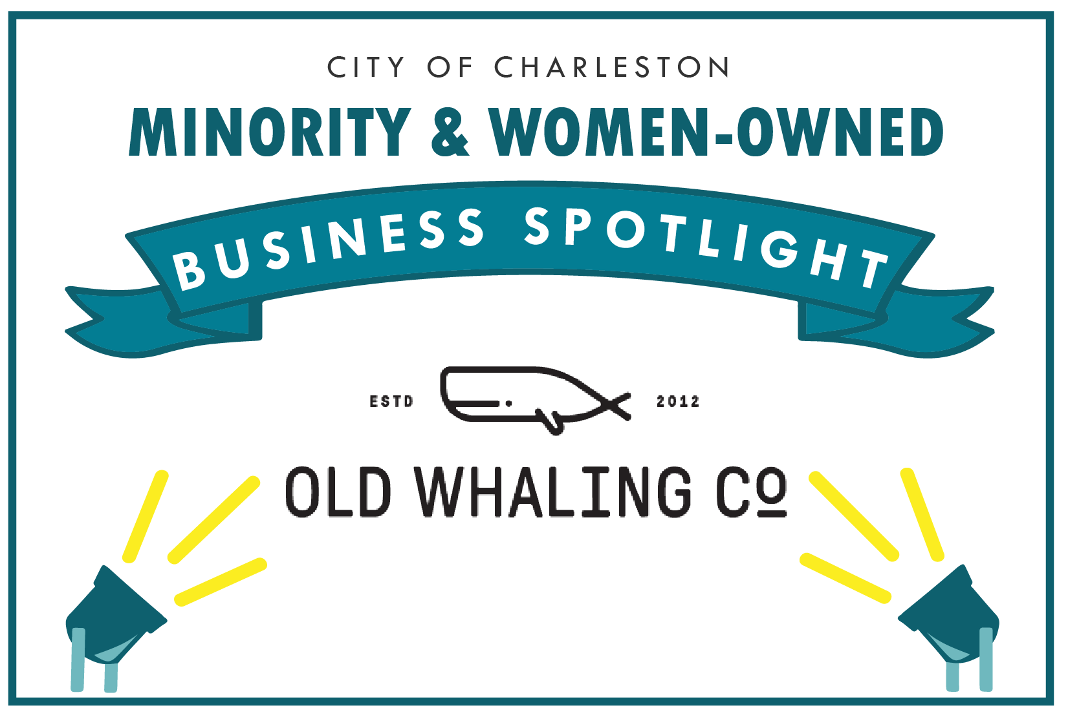
The City of Charleston is honored to Spotlight Old Whaling Co. as our March2021 Business Spotlight.

Old Whaling Co.
Owner or Manager: April Budney
Address: 1941 Savage Road Suite 500F Charleston, SC 29407
Email: april@oldwhalingcompany.com
Website: www.oldwhalingcompany.com
Phone: (843) 619-7799

How long have you been in business? 8 years
Number of employees: 27

Please give us a brief description of the business:
Old Whaling Co creates handcrafted, sea inspired bath and body product. We have three retail stores downtown, wholesale to over 1,000 retailers and have a booming e-commerce business shipping products all over the country.

What is your business philosophy/mission statement?
Our mission is to create beautifully crafted, gentle, and affordable bath and body essentials inspired by the sea.

Why does this business deserve to be a M&WBE Spotlight Business?
We have been in business eight years and started in the Charleston City Market. In those eight years we have worked tirelessly to built a beautiful brand that our customers and team members love.

Growth: How has this business grown since its establishment (in employees or revenue)? What is the vision and potential for growth in the future?
Our employees have gone from 0 back in 2015 to 27 in 2021. Our revenue in 2019 was 2.4M and last year was just shy of 3.4M. Adding one million in revenue in a pandemic with all our stores closed for months on end is pretty fantastic!

What activities does your business engage in to support the broader community?
We support many organizations throughout the Charleston area including grass roots organizations, schools, museums, the arts, and more, but do not believe in advertising it to the world. We don’t give so we can pat ourselves on the back, we give because we enjoy supporting our community and lifting up others.

What sets your business apart from competitors?
The way we do business. We do our absolute best to treat everyone with kindness and respect. In regards to our products - it’s very important to us to provide incredible value that wows our customers. Our products are not only extremely effective, they’re priced very competitively.

What's one valuable lesson you've learned that you would share with other business owners?
Being a business owner means serving others - your team, employees, and community.

Tell us an interesting & fun fact about your business:
We are the only Charleston City Market vendor ever to run an outdoor, indoor, and night market space simultaneously. It’s that grit and determination that’s grown our business.

