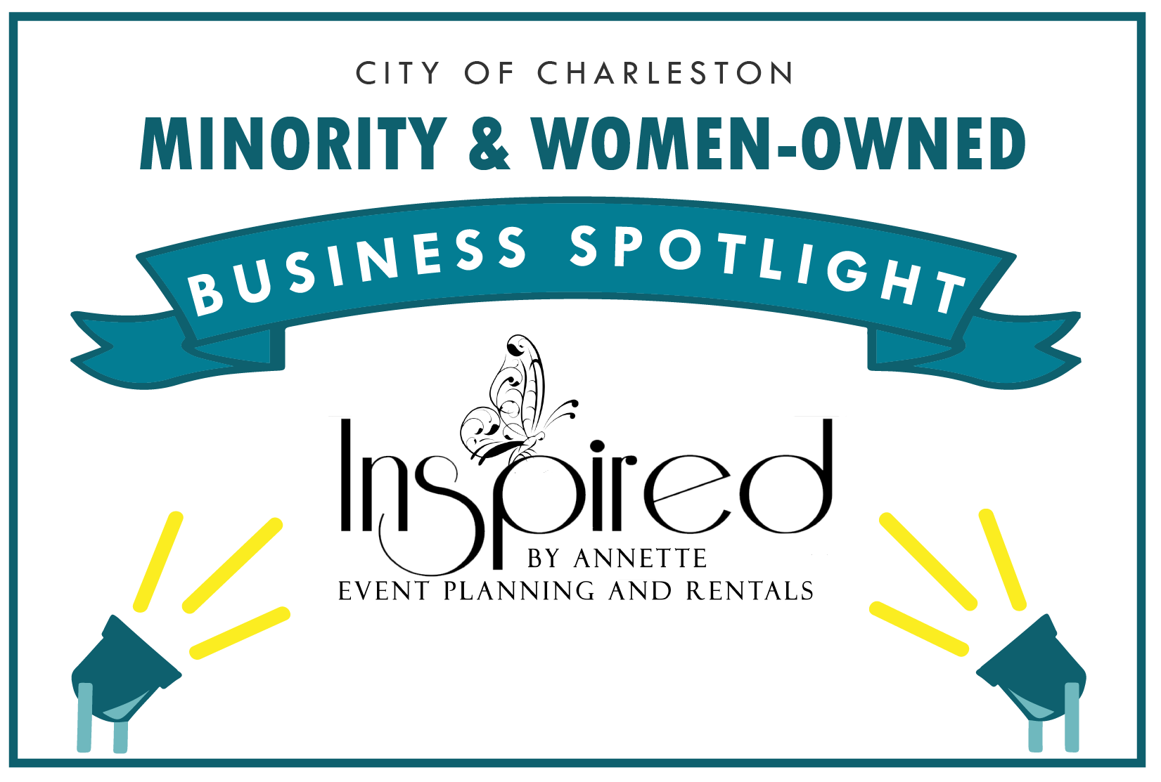

Inspired By Annette Event Planning & Rentals
Owner or Manager: Courtney Scipio
Address: 7910 Dorchester Rd, North Charleston, SC 29418
Email: info@inspiredbyannette.com
Website: www.inspiredbyannette.com
Phone: (843) 225-1077

How long have you been in business? 8 years
Number of employees: 4 full time & 3 part time

Please give us a brief description of the business:
Inspired By Annette is a full service event company that provides event rentals, event design and venue space as well. We like to call ourselves the "one stop shop" when it comes to planning your wedding or special event.

What is your business philosophy/mission statement?
We develop relationships that make a positive difference in our customers lives. We provide outstanding customer service and quality products. We work together to meet the needs of our customers and to help the company win. We value our people, encourage their development and reward their performance. We exhibit a strong will to win in our marketplace and in every aspect of our business.

Why does this business deserve to be a M&WBE Spotlight Business?
We appreciate the opportunity to be the spotlight business. I am a minority and there are not a lot of women owned event rental equipment businesses in the local Charleston area. This is usually a male dominated industry so I hope that this gives women the inspiration that they can do it too! I hope this inspires someone to not be afraid of starting small and go after it!!

Growth: How has this business grown since its establishment (in employees or revenue)? What is the vision and potential for growth in the future?
IBA has grown tremendously over the years. I started the business in my garage, then moved to a 400 sq/f office to now a 6000 sq/f space. Started off the business with just my husband and I and shortly after that we hired our first part time employee. Now we have four full time employees and three-part time.
I plan to continue to grow my business and add new rental equipment and there is a huge project we are working on at this time and will announce at a future date.

What activities does your business engage in to support the broader community?
I lost my mother to domestic violence so I am a volunteer and sit on the survivors council board with My Sisters House - a local non profit serving victims of domestic violence. We have sponsored food drives, and gave cash donations to local organizations for breast cancer awareness.

What sets your business apart from competitors?
We truly care about our customers. I personally think the story behind my company sets us apart. With my mother "Annette" always having a dream and desire to start her design business but tragically losing her life to domestic violence. My mother would always talk about starting and would try to get me involved but I was in the corporate world and that was not my passion and focus at that time. Fast forward to about six months after she transitioned, I planned my daughters birthday party and handled everything from decor, cake, food, etc. Friends and family loved the decor and asked for me to design their events and one thing led to another. From there sparked a new passion for designing events and then Inspired By Annette was born. I always tell people that Inspired By Annette is the flower that has blossomed out of the tragedy of losing my mother.

What's one valuable lesson you've learned that you would share with other business owners?
There are too many to list just one!! Lol!! Don't be afraid to start small!! Make sure that you are taking care of the back end of your business - know your numbers, make sure you have the proper insurance and bookkeeping system in place, keep personal and business accounts separate and don't be afraid to fail!!!

Tell us an interesting & fun fact about your business:
Everyone thinks that I am Annette because of the name of the company but Annette is my mother!

