M&WBE December Spotlight
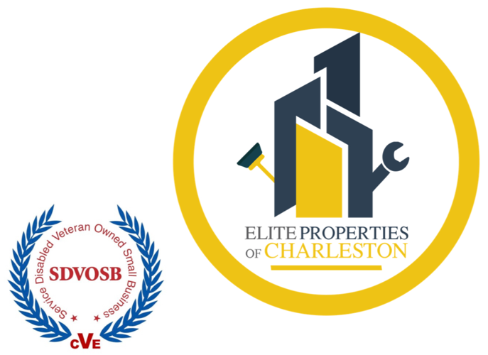
Elite Properties of Charleston
Larry Broadnax | www.epcharleston.com
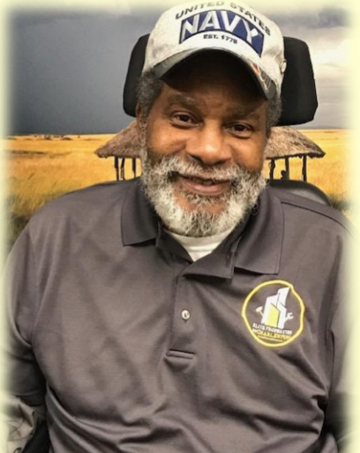
Elite Properties of Charleston is a Service-Disabled Veteran Owned company providing professional cleaning and maintenance services. They pride themselves on establishing relationships with their clients to build trust and confidence that their needs will be executed to elite parameters.

Larry Broadnax started Elite Properties of Charleston in September 2014. Elite Properties of Charleston is located in Goose Creek, SC and currently has six employees offering various janitorial services from business offices to rental condos, customizing the exact needs for cleaning and maintaining a property.

Elite Properties of Charleston started with humble beginnings. Mr. Broadnax financed his start-up and did the leg work to get his business off the ground with help from the Small Business Development Center (SBDC) and Small Business Administration. Elite Properties of Charleston has grown substantially with NAICS codes in several industries and with contracts throughout the Carolinas including the City of Charleston.

Elite Properties of Charleston offers the following services:
- Janitorial/Office Cleaning
- Janitorial Supplies
- Stripping/Waxing Floors
- Facilities Maintenance
- Post Construction Cleanup
- Carpet Cleaning
- Pressure Washing

