M&WBE September Spotlight:
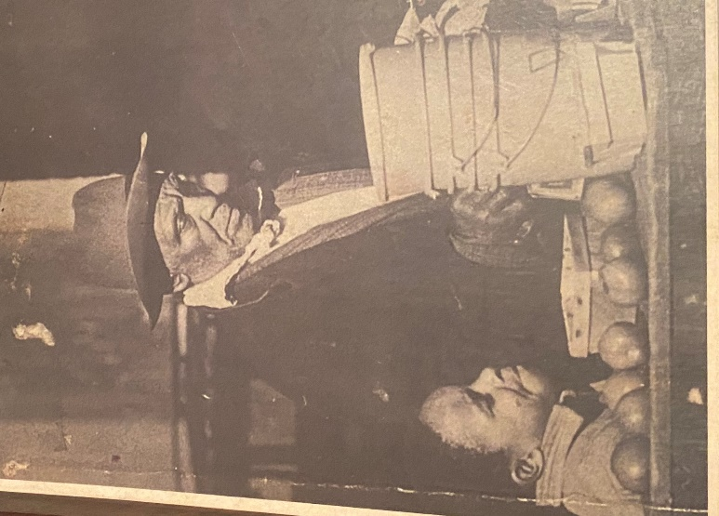
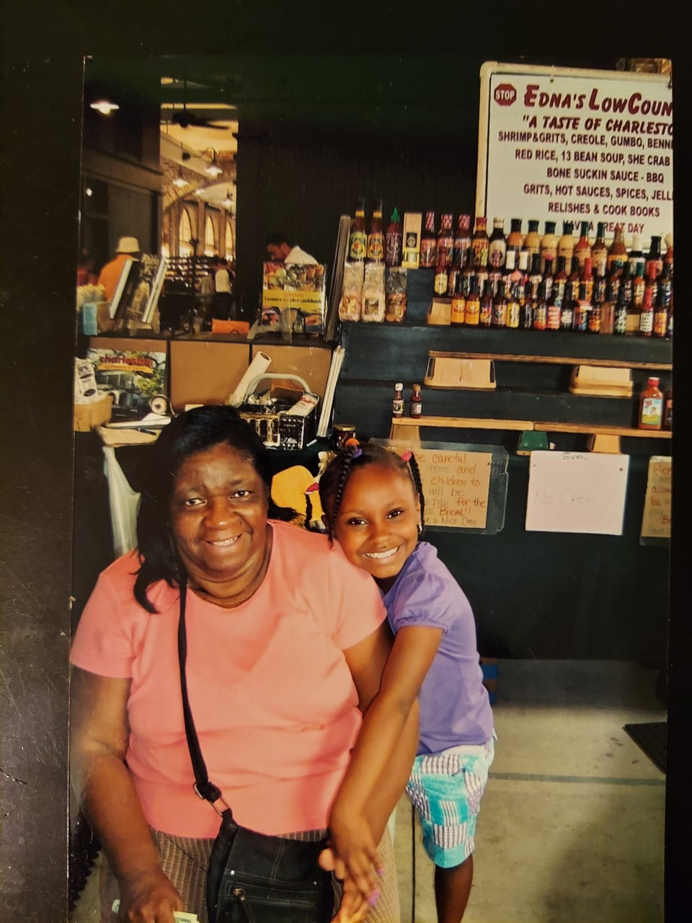

Edna’s LowCountry
Charleston City Market
Edna & Jonzetta Taylor | jonzettat0619@gmail.com
Edna’s LowCountry has been in business since 1910. Jonzetta’s grandfather, Walter Wright Sr, began by selling fruits and vegetables along with his mother and 2 brothers. In the late 1960s, her mother, Edna, took on the business with the help of her 4 small children, Charles, Anthony, Benjamin, and Jonzetta.
We are a family-owned and operated business specializing in hand-mixed spices, rice and bean mixtures, hot sauces, cookbooks and other food products specific to the Charleston area.
Our mission is to give our customers a "Taste of Charleston" by providing delicious, travel-friendly food products while inspiring other entrepreneurs starting out to NEVER GIVE UP.
Our family was one of the first to start off at the Charleston City Market. Through various obstacles including racism and poverty, we've stayed. We pride ourselves on remaining a family business ensuring our customers receive a memorable experience and that they walk away feeling better than they came.
Our business has grown leaps and bounds over the years. I remember a day back in the 60s when my mom only made a quarter and it fell into the flood water. While we'll never forget where we came from, things have gotten much better for us. Edna's LowCountry has afforded us the opportunity to live comfortably and for that we are grateful. In the future, we plan to have Edna's grandchildren take over the business and continue building upon our family legacy.
Over the years, we have made numerous donations to local churches and other non-profit organizations. We have also employed those who may not be able to find employment elsewhere, providing them the opportunity to gain skills in effective communication, customer service and sales.
What sets us apart is our unwavering focus and dedication to providing genuine southern hospitality and exceptional customer service.
If we could only share one thing, it would be the value of preparation, perseverance and adaptability. Over the years we've faced many challenges, including the off-season and most recently the City Market being closed due to Covid-19. Despite these challenges, our business has been able to sustain.
In 1989, we were featured in Food&Wine Magazine. In 2009, we were featured on Man vs Food (Season 2, Episode 3) with Adam Richman. We've also been highlighted by the local news and newspaper, BBC (The British Broadcasting Corporation) in London as well as NHK in Japan.
