CITY ORDINANCE 2020-134 (FACE MASK ORDINANCE) FAQs:
Should you have any additional questions, please submit questions to:
covid-19businessinquiry@charleston-sc.gov

General Questions
Q: Why do I need to wear a mask?
A: According to Center for Disease Control (“CDC”), everyone is at risk for getting COVID-19 if they are exposed to the virus. Some people are more likely than others to become severely ill, which means that they may require hospitalization, intensive care, or a ventilator to help them breathe, or they may even die. COVID-19 is most commonly spread through respiratory droplets produced when an infected person sneezes, coughs or talks. These aerosols can remain suspended in the air for up to three (3) hours and be transmitted at least thirteen (13) feet.
Masks are effective in blocking or at least limiting your exposure to these contagious viral droplets and particles. Because we do not always know who is infected (many coronavirus cases are asymptomatic), you should also wear a face covering to protect others.
Q: What kind of mask should I wear?
A: The CDC recommends people wear washable cloth coverings to ensure there are enough surgical and N95 masks for medical workers.
Here’s a breakdown of how common masks work.
Cloth face coverings, bandannas, and DIY masks: Homemade face coverings don’t stop you from inhaling potentially infected particles, but they provide a barrier that may prevent the spread of droplets by asymptomatic individuals. When worn correctly, these masks also keep the wearer’s face clean and reduce the likelihood that people will touch their faces.
Surgical masks: Also known as medical and procedure masks, these are used in hospitals to reduce the number of potential contaminants that mask wearers release into the immediate environment. These loose-fitting masks can protect against large splashes of droplets.
Q: Where can I get a face covering?
A: Face coverings are widely available at retailers in the City of Charleston. You can also use a bandana, scarf or piece of fabric as a face covering. Here is information from the Centers for Disease Control on how to make and wear face coverings: https://www.cdc.gov/coronavirus/2019-ncov/prevent-getting-sick/how-to-make-cloth-face-covering.html.
Q: What are the consequences for not wearing a face covering?
A: For a first offense, an individual shall be deemed guilty of an infraction and subject to a fine of one hundred dollars ($100.00) for the first offense; two hundred dollars ($200) for the second offense; and five hundred dollars ($500) for the third and subsequent offenses.
Q: Who enforces this ordinance?
A: City of Charleston Livability Code Enforcement Officers, police officers, fire fighters, and other first responders are responsible for enforcement. With the exception of their own employees, businesses shall not have responsibility for enforcement but shall post conspicuous signage at all entrances informing patrons of face covering requirements.
Q: What is the proper way to wear masks?
A: The World Health Organization has provided the following guidelines for effectively wearing a face mask:
- Before putting on a mask, clean hands with alcohol-based hand sanitizer or soap and water.
- Cover your mouth and nose with the mask. If using a surgical mask, pinch the stiff border at the top to mold around your nose for a secure fit.
- Avoid touching the mask while using it. If you do, clean your hands immediately.
- Replace the mask with a new one as soon as it is damp.
- To remove the mask, take it off from behind (do not touch the front of mask); discard immediately in a closed bin; and wash or sanitize your hands.
- Do not share masks.
- Disposable masks can be re-used if you are careful not to contaminate the inside. Storing them in a small brown paper bag is a good way to keep them clean in between uses.
- Cloth masks should be washed daily.

Q: When does the requirement expire?
A: Emergency Ordinance 2020-134 which currently governs mask requirements was most recently renewed on January 12, 2021 in Emergency Ordinance 2021-02 and is set to expire March 12, 2021.

Exemptions
Q: Do kids have to wear face coverings?
A: Children under 10 years old are exempt from the face covering requirement, provided that adults accompanying children ages two through 10 shall use reasonable efforts to cause those children to wear face coverings while inside the enclosed area of any retail establishment or food service establishment.
Q: I have a medical exemption. Do I need a doctor’s note?
A: If you receive a ticket for not wearing a mask, and believe that you have an appropriate medical condition, you have the right to provide any such evidence to a judge to have the ticket dismissed.
Activity/Business Specific Questions
Q: Do I have to wear a face covering while outdoors?
A: Yes, face coverings are required while outdoors in public spaces. However, face coverings are not required while exercising, outside as long as physical distancing of six feet is maintained between you and anyone that is not a part of your household.

Q: Do I have to wear a face covering while swimming?
A: No, face coverings are not required while swimming, but physical distancing should be maintained. Face coverings are required in locker rooms.

Q: Do I have to wear a face covering while shopping?
A: Yes, face coverings are required while entering, exiting, waiting in line to enter, and while inside places of business including, but not limited to, grocery stores, retail stores, pharmacies, health care facilities, restaurants and bars (including outdoor seating for such facilities), gyms and similar facilities. Additionally, face coverings are required at all times while in public, so please do not remove your face covering after you have exited a store until you are in your private vehicle, home, or no longer in public.
Q: Do I have to wear a face covering while at a bar or restaurant?
A: Yes, face coverings are required while entering, exiting, waiting for a table and ordering. Face coverings can be removed while eating or drinking but must be worn otherwise. If a patron is not seated at their table or at the bar, a face covering is required.
Q: Are restaurant employees only working in the kitchen required to wear masks?
A: Yes. Although the kitchen may not necessarily be considered “open to the public,” if the individual cannot maintain a distance of six feet or more from another individual, then the mask would be required. OSHA has also recommended all kitchen chefs and staff wear masks. This information can be found at: https://www.osha.gov/Publications/OSHA4045.pdf.
Q: Do I have to wear a mask if it creates a safety hazard for my occupation?
A: No. A mask would not be required in such situations that it would cause a potential safety hazard for an individual during their occupation. OSHA outlines specific situations where mask would not be feasible and are therefore exempt under City ordinance. https://www.osha.gov/SLTC/covid-19/covid-19-faq.html
Q: Do I have to wear a face covering at work?
A: If you interact with the public while at work, a face covering is required, otherwise face coverings are not required in private, individual offices. You should consider wearing a mask when in the common areas such as hallways, elevators, and bathrooms, even if you are not interacting with the public.
Q: Do I have to wear a face covering in my car?
A: No, face coverings are not required while inside a personal or commercial vehicle that is not a public transportation vehicle, taxi, or ride sharing service. It is recommended to wear a face covering if you cannot maintain six feet of physical distancing between you and someone who is not a member of your household.
Q: Can I carry a concealed weapon and wear a face covering?
A: Yes, face coverings can be worn while carrying a concealed weapon provided you have a concealed weapons permit. If a crime is committed while concealing your identity with a face covering of any kind, it may be an aggravating factor at the time of sentencing if convicted for that crime.

Q: Does this Ordinance apply to my wedding?

A: Yes. Face coverings are required in any building open to the public and while interacting with people in outdoor spaces. Masks are not required when eating, drinking, or smoking. In addition, the Governor’s Executive Order 2020-50, requires that “all persons in attendance [of a large crowd or gathering] must wear a face covering as a condition of entry or participation. This EO goes even further and limits capacity to 50% or 250 people, whichever is the lower capacity.

Clarification Regarding Masks in Gyms
The City of Charleston’s current mask ordinance (2020-134) is in response to the rising infection rate and death toll of COVID-19 across the country and in our own community. This ordinance requires masks to be worn at all times with few exceptions.
Due to the number of inquiries we have received regarding the use of mask in gyms and fitness studios, the City would like to clarify the application of the ordinance in a workout setting. Masks are required at all times. However, an individual with a health condition that prevents him or her from wearing a mask while exercising is exempt (2020-134, Section 4(1)). An individual engaged in exercise activity indoors may also be exempt only when it is not feasible for the individual to wear a mask during exercise activity (i.e. on the treadmill, actively playing basketball on a court, etc.) (2020-134, Section 4(12)). However, the mask is required while not engaged in this exception (i.e. between workout stations).
Further, Governor McMaster issued guidelines for gym upon their reopening. Below are a few examples:
- Social distancing signage and floor markers put in place for traffic flow, maintaining 6 feet of distance in all gym activities, and roping off of disabled equipment.
- Best practice for group exercise classes is to designate a 10x10’ area for each member and limiting movement and interaction outside of that area during class.
- Limiting class size (even if space permits more) to 10 participants to decrease the number of people congregating before and after class, regardless of building size, or 5 people per 1,000 sq. ft of space, whichever is less.
- No contact training and no equipment sharing training sessions.
- Workout duration should be adjusted to accommodate time before and after to disinfect the equipment.
- Schedules should be adjusted as to minimize traffic and congestion before and after class.
- Water fountains are for use ONLY to fill water bottles, no drinking directly from the fountain.
- No use of saunas or steam rooms, as a minimum safe distance of 6 feet cannot be maintained.
- Only every other piece of cardio equipment will be available for use.
- Complete list of recommendations: https://accelerate.sc.gov/sites/default/files/Documents/FINAL_Re-Opening%20Guideline_Fitness%20Centers%2CGyms%2CYMCA2.pdf

As positive COVID-19 cases continue to rise, it is imperative that individuals continue to be diligent. The CDC continues to emphasize that wearing masks helps prevent the spread of the virus, and the City of Charleston aligned with best practices and recommendations from our medical community, continues our enforcement of the mask ordinance for the protection of our community.

Report A COVID-19 Related Health & Safety Concern

Contact the Citizen Services Desk at (843) 724-7311 or go online to: https://www.charleston-sc.gov/1884/Citizen-Services-Desk to report COVID-19 violations. You can also email your concerns to covid-19businessinquiry@charleston-sc.gov.
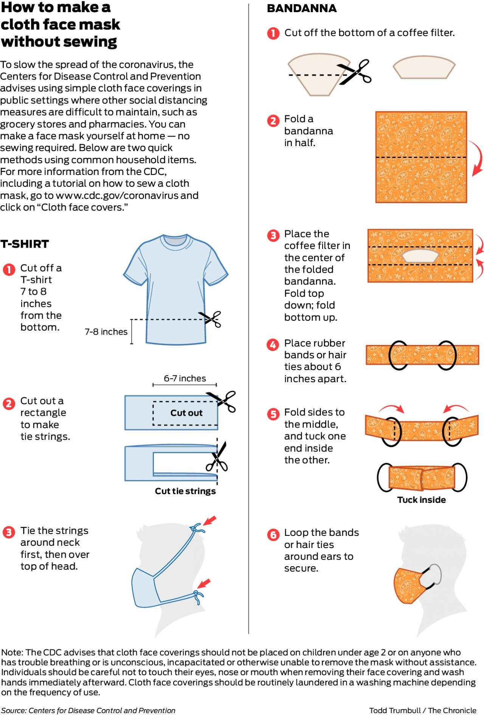

https://www.cdc.gov/coronavirus/2019-ncov/prevent-getting-sick/prevention.html

