M&WBE May Spotlight:


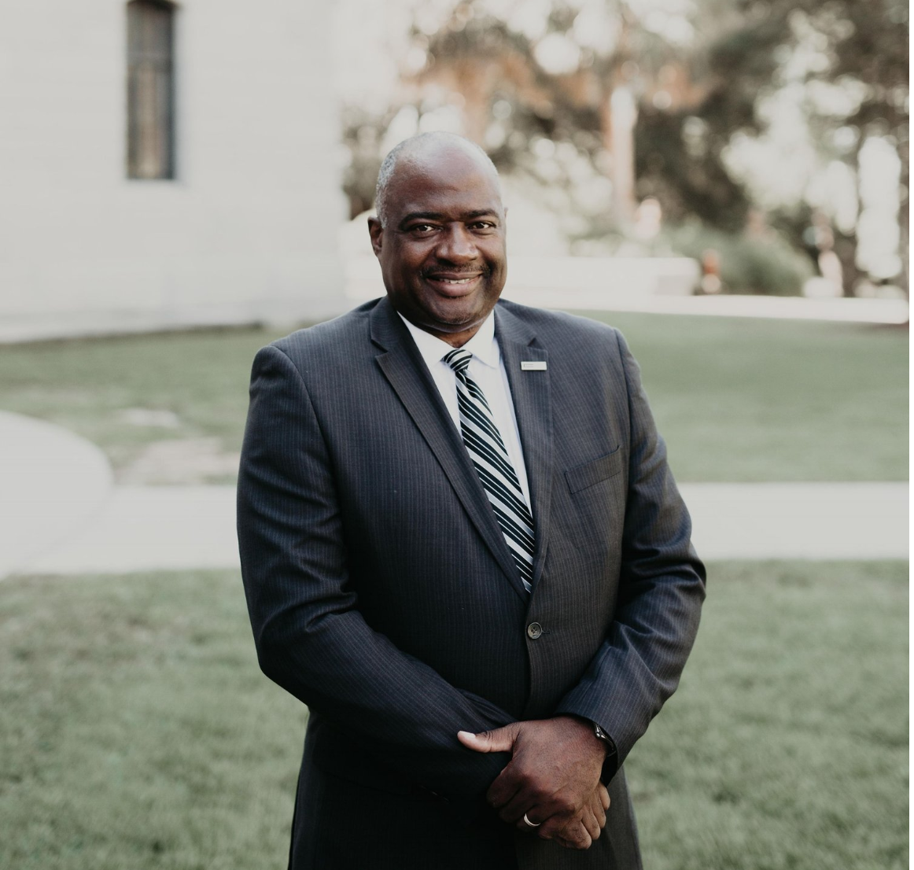

Dale Collier is the Founding Principal of Brownstone and serves as President and CEO. Established in 2005, Brownstone Construction Group is currently celebrating its 15th year in business. Brownstone is a full-service management, architecture, and engineering firm. We offer a variety of services from construction and program management, architecture, engineering, master planning, and site management. We have a record of exceeding our clients’ goals and expectations by completing projects on time and within budget. During our tenure in Charleston, Brownstone projects include our work with The City of Charleston, Charleston County School District, The City of North Charleston and the Medical University of South Carolina. We are currently engaged on the most significant project of many of our careers with the City of Charleston, The International African-American Museum (IAAM) with Turner Construction Company.

Outside of our success as a certified MBE firm, we strive to aid other M&WBE businesses by offering opportunities during our various projects. We have hosted M&WBE meet and greets, worked to exceed M&WBE participation goals, and have held several meetings and seminars advising M&WBE businesses on contracting opportunities available on our construction projects.
Brownstone started with three (3) employees and has now grown to 34 employees across four offices in Charleston, Columbia, Savannah, and our newest location in Charlotte. Our vision for the future includes growth that will be accomplished by diversifying the services that we offer our clients. In addition to Construction Management, we are also engaged in providing architectural, engineering and transportation inspection services.

Brownstone is proud to play an active role in the communities in which we operate. We have partnered with local school districts in raising funds for school supply drives, participate in annual STEM career fairs, and we are proud to have employees who participate in events to support the local National Society of Black Engineers (NSBE) efforts in career development.

As a proponent of diversity, Brownstone itself has also focused on having the ability to provide a diverse offering of services to clients in lieu of offering a singular product or service. In that regard, over its tenure, Brownstone has expanded to provide Architecture, Transportation Design and Inspection, and Construction Management At-Risk Contracting Services.

What’s one valuable lesson you’ve learned that you would like to share with other business owners? One person cannot do it all; therefore, organizations cannot be successful without good people.

